**Student’s Project**

**MOROCCO**

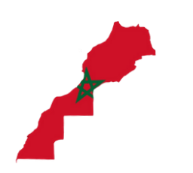

**A New Vision to Save Life Below Water**

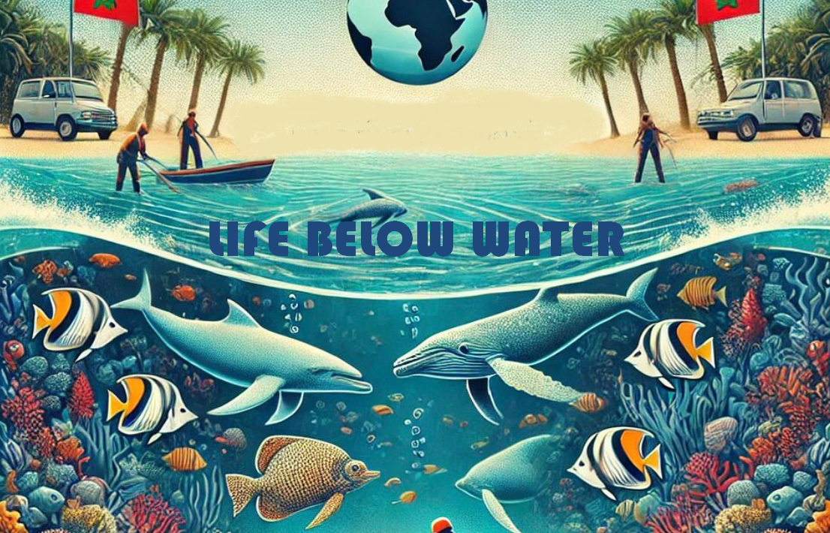

**The researcher : Nour ElHouda Boukhita**

Supervised by : Prof. Mohamed Fettah

School: Moulay Ismail High School

**Outline**

1. **Part One (Theory) ...........................................................**
2. **Introduction.**
3. An overview of SDG number14: "Life Below Water".
4. Importance of oceans and marine life to global ecosystems and human survival.
5. The state of Moroccan oceans and ecosystem.
6. Overview of Morocco’s marine biodiversity.
7. **Challenges and dangers to marine life.**
   1. Pollution.
   2. Overfishing.
   3. Climate change and ocean acidification.
8. **Innovative solutions to save life below water.**
   * Maintaining integrated approaches combining technology, policy, and education.
   * Spreading national policy recommendations and promoting international laws.
   * Encouraging community-driven initiatives for saving the ocean.
   * Adoption of Sustainable Fishing Practices.
   * Climate change mitigation and adaptation.
9. **Part Two (Practice) ....................................................**

* **Creating a poster about life below water.**
* **Conducting street interviews about life below water.**

**Abstract**

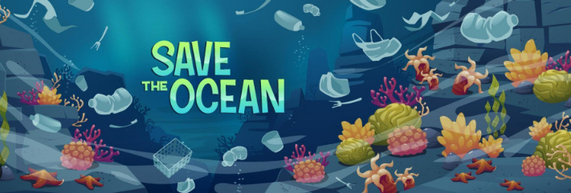

**This research presents a new vision for addressing the challenges facing marine ecosystems with a particular focus on achieving Sustainable Development Goal (SDG) 14: "Life Below Water. In fact, oceans and marine biodiversity play an important role in maintaining global ecosystems and supporting human survival. In Morocco, the oceans are home to rich biodiversity. However, this ecosystem faces numerous dangers like pollution, overfishing and the impact of climate change which causes ocean acidification and rising temperatures.**

**The preservation of life below water is not only crucial for maintaining ecological balance but also for ensuring the sustainable development of coastal nations like Morocco which depends on marine resources for its economy and livelihoods. As a matter of fact, the escalating threats to Morocco’s marine ecosystem have harmful consequences on its biodiversity and the livelihoods of coastal communities. While overfishing and pollution deteriorates water quality, climate change exacerbates habitat destruction. Therefore, addressing these challenges is useful for safeguarding marine life and sustaining the well-being of Morocco's population.**

**To combat these issues, the research identifies key strategies for marine conservation. These strategies generally aim to balance ecological restoration with the socio-economic needs of communities reliant on marine resources.**

**Ultimately, this research provides significant information to foster a deeper sense of responsibility and urgency in addressing marine conservation challenges. Through these combined details, this research aspires to inspire collective action and contribute to the long-term preservation of Morocco’s marine ecosystems for future generations.**

"Water is a source of health and vitality; to pollute it is to harm the balance of life. Protecting it is among the noblest acts."

Ibn Sina